Annual report NGO Our action (NVO Nasa akcija) - 2019
Implemented (or ongoing) NGO projects Our action:
1. "Be a change, show courage" - under the auspices of the Civic Courage Foundation
2. "Earth Day 2019" - under the auspices of the Public Institution Morsko Dobro
3. "Youth for a clean Adriatic" - under the auspices of Beyond plastic Med and the Prince Albert II Foundation of Monaco
4. Project and award for "Invitation to non-governmental organizations for submission of proposals for design, production and installation of art installations from collected and processed wood from beaches" from the project "WELCOME" (WatEr LandsCapes sustainability thrOugh reuse of Marine littEr) under the auspices of Interreg IPA CBC Italy -Albania-Montenegro ”2014-2020
Realized (or in progress) independent projects of young NGOs Our action:
1. Project "Volunteers Unlimited" submitted to the project Generation Unlimited, Podgorica
2. UpShift project "Remodeling and refurbishing of grade school Njegos in Skaljari", Kotor

Implemented (or ongoing) projects as partners:
1. "Art vs. Conflict" - Montenegro partner implementer, partners Demos, Bosnia and Herzegovina (project management for Montenegro)
2. "Y O U t h d r i v e - Awareness Raising Program for Waste Management and Empowering Legislators to Respond." - Second IPA Cross-Border Cooperation Call Bosnia and Herzegovina - Montenegro (2014-2020)

NGO activism Our action as a member of organizations / coalitions:
1. Coalition 27 - Monitoring the implementation of the chapter, EU delegation project (Green Home partners)
2. SOS Adriatic and SOS Montenegro - against wells on the Montenegrin coast
3. Balkan River defense group - for the protection of rivers against the construction of small hydropower plants
4. Civil Coalition for Protection of Water Rights and Prohibition of Water privatization

NGO Our action - volunteer support to others (strengthening communities):
1. Support to the citizens of Bar in the fight for cypresses, Bar (Jan 27)
2. Support to the citizens of Bar in the fight for the Cypresses, Bar (Feb 3)
3. Volunteer support to the Association of Gorica Lovers, Podgorica (Feb 10)
4. Support to the citizens of Bar in the fight for the Cypresses, Bar (Feb 10)
5. Support to the citizens of Bar in the fight for the Cypresses, Bar (Feb 17)
6. Support in action in the Mediterranean Garden in Gorica, Podgorica (Feb 24)
7. Support to the Safe Women's House "Breaking the Silence - Against Violence Against Women", Podgorica (Feb 24)
8. Volunteer support to the Kotor Winter Festival, Kotor (March 2)
9. Support 8. March Women's March, Podgorica (Mar 8)
10. Volunteer support Beo Art 2015 guest appearance in PGi BD, (March 8-11)
11. Volunteer support to the Association of Gorica Lovers, Podgorica (March 10)
12. Volunteer support to the Mediterranean Garden Gorica, Podgorica (March 17)
13. Volunteer support to the planting action Ljubovic, Association of Business Women of Montenegro (March 30)
14. Volunteer support to the Mediterranean Garden Gorica, Podgorica (March 31)
15. Volunteer support to the Mediterranean Garden Gorica, Podgorica (May 25)
16. Volunteer support to the action of arranging the fortress Mogren, Budva (May 25)
17. Volunteer support X Waters Montenegro 2019, Risan (May 20)
18th Volunteer Support to the Kotor Children's Theater Festival, Kotor (Jul 1-15)
19th Volunteer Support to Searock Festival, Kotor, (Jul 20)
20th Volunteer Support to the Kotor Summer Festival, Kotor (August 8)
21. Volunteer support Bjelasica Ultra Trail, Kolasin (August 16)
22. Volunteer support Boka sprint triathlon 2019, Perast (September 8)
23. Volunteer support Montenegro Pride 2019, Podgorica (September 21)
24. Volunteer support to the Association of Gorica Lovers, Podgorica (September 22)
25. Volunteer support Kayak fest 2019, Tara Canyon (September 22)
26th Volunteer Support to the 5th International Book Fair, stand KFPD (October 1)
27. Volunteer support for the Open Days of Science, Podgorica (October 2 - 5)
28. Support to Arcadia Academy and the Red Cross in collecting and sorting donations, Kotor (October 11)
29. Volunteer support to the Association of Gorica Lovers, Podgorica (October 13)
30. Volunteer support to the first Upshift action of OS Njegos, Kotor (November 16)
31. Volunteer support to RYCO project "Art vs. conflict", Kotor (November 16)
32. Volunteer support to the competition "In search of human rights", Podgorica (December 6)
33rd Volunteer Support for the New Year's Donkey Ball, Martinici (December 8)
34. Volunteer support for planting action, Dajbabska gora, Podgorica (December 15)
35th Volunteer Support 200th Action of the Association of Lovers of Gorica, Podgorica (December 29)
Successes and education of our youth:
1. Third place in the overall competition of Generation Unlimited projects (Dejan Besovic, Filip Drobnjak, Dusan Vukadinovic and Slavo Bozovic), (Feb 2019)
2. Six members successfully depended on the "School of Young Leaders" (Jana Raicevic, Petar Raicevic, Kristina Jankovic, Brajan Martic, Milo Popovic, Sofija Knezevic, Sofija Knezevic), (Feb 2019)
3. Scholarship to the prestigious faculty of our member Marko Susic. (Feb 2019) and departure (August 2019)
4. Workshop "Connecting young activists from the civil sector and political parties", (Dejan Besovic) Petrovac (March 3-4)
5. Scholarship and going to the Scottish high school of our member Matija Pejovic (August 2019)
6. Scholarship and going to the USA to attend the high school of our member Miki Radulovic (August 2019)
7. Scholarship and trip to Italy for handball and kayak training of our member Ivana Radonjic (August 2019)
9. Scholarship and going to Italy to the Faculty of Psychology in Padua of our member Marta Martinovic (September 2019)
10. Workshop "UpShift" team Podgorica - Brajan Martic, Milo Popovic, Aleksa Obradovic and Tara Simovic (October 2019)
11. Workshop "UpShift" team Kotor - Nadja Srdic, Ivana Rapovac, Dejana Vujovic and adhoc Jelena Petrovic
12. Training for peer educators - Andrea Stevovic, Andrea Popovic, Milo Popovic (October and November 2019)
13. Academy for active participation of young people, Initiative "Let's give a voice to young people", Dejan Besovic (November 2019)
14. Scholarship and going to France to the Faculty of Arts of our member Milena Mandic (November 2019)
15. Scholarship and going to Portugal to the Faculty of Arts of our member Aleksandra Drecun (November 2019)

NGO educational workshops for young people:
1. Workshop "Strategic planning and SWOT analysis", Podgorica (Jan 3)
2. Workshop "My first CV and my real move", Podgorica (Feb 27)
3. Lecture "Youth teaches Youth - volunteer for your future", "Danilo Kis" high school, Budva (Feb 27)
4. Promotion "Volunteers - natural girls who change the world", Montenegro (March 8)
5. Lecture "Youth teaches Youth", Economic high school, Niksic (March 22)
6. Workshop "We deal with ethics and fake news" with NGO 35 mm, Kotor (Jun 11)
7. Workshop "Brand audit and waste analysis" with Zero Waste Montenegro, Podgorica (September 16)
8. Excursion - walking marathon Kotor-Lovcen-Kotor and Kotor-Krsta-Kotor (September 29)
9. Workshop "My first CV and career counseling", Kotor (October 9)
10. Workshop "My first CV and career counseling", Podgorica (December 10)
11th Workshop on volunteerism for young volunteers Forum MNE, Podgorica (December 21)
12. Manifestation "What are we and have we done enough in 2019? Youth for Youth", Budva (December 26)

NGO Our action leaders are made in field activities:
1. Action to clean the road to Troica, Kotor / Tivat (March 2)
2. Cleaning action Plav / Lim river, (March 23)
3. Ecological action "Earth Day", cleaning the coast of Kotor (April 20)
4. Coastal cleaning action, Traste Bay, Herceg Novi / Tivat (Jun 9)
5. Cleaning action Gurdica, Kotor (Jun 25)
6. Action to clean Skurda, Kotor (Jul 9)
7. Coastal cleaning action Sveti Marko Island and Cvijeca Island, Tivat (August 1)
8. Mask "Angry Poseidon" - Kotor Summer Festival, Kotor (August 8)
9. Stoliv Coast Cleaning Action (International Coast Cleaning Day), Kotor (September 21)
10. Mask "Angry Poseidon" - EU Info Center, Podgorica (September 30)
11. Refreshment of playgrounds / premises, Old Airport, phase 1 - Podgorica (October 28)
12. Action to clean Ribnica, Podgorica (November 10)
13. Action cleaning the beach Maljevik, Sutomore (December 1)

Youth and humanitarian activities:
1. Visit to the Home for the Elderly Bijelo polje, BP (March 23)
2. Humanitarian Music Evening for Melek, Podgorica (March 19)
3. Blood Collection Action, Bar (May 25)
4. Humanitarian action fundraising for Jovan Cenic (Searock), Kotor (Jul 20)
5. Humanitarian Muljan Dance Evening for Jovan Cenic, Muo (August 30)
6. Humanitarian Music Evening for Jovan Cenic, Podgorica (September 11)
7. Donor Day, Podgorica (September 28)
8. Volunteer action in asylum, Podgorica (October 30)
9. Volunteer support to the humanitarian children's party NGO Ray of sunshine, Podgorica (November 24)
10. Humanitarian action of collecting packages for the Association for Assistance to Persons with Disabilities in Psychophysical Development, Niksic (Dec 17-25)
11. Humanitarian action for the Sorovic family, Podgorica (December 29)

Volunteer / activist camps:
1. Volunteer support Ocean lava Montenegro 2019, Kotor (May 11-12)
2. Youth camp "Landscaping for the Kotor Children's Theater Festival", (June 22-23)
3. Youth educational camp Ponte Veslo, Lustica (September 21-23)
4. Volunteer support Black lake Xtreem triathlon, Zabljak (October 2 - 6)
5. Educational exchange and education, Brcko, Bosnia and Herzegovina (November 1-4)

Informed youth Kotor:
1. Maintenance of the face book page "Info center for youth Kotor" (from Jun 8, 2018)
2. Workshop "Youth teaches youth - Why volunteerism?", Kotor (February 2019)

Awards / diplomas / certificates of appreciation in 2019:
1. Acknowledgment from the NGO 35mm for the partnership in the workshop "We deal with ethics and fake news", Kotor
2. Acknowledgment in support of the 27th Kotor Children's Theater Festival, Kotor
3. Acknowledgment for the support of the Summer Kotor Carnival 2019, Kotor
4. Acknowledgment from the Municipality of Podgorica for the action of cleaning Ribnica, Podgorica
5. Award from the EU Delegation for contribution to the project "Be an example. Get involved!", Podgorica
6. Acknowledgment for support, attention and humanity shown to children and youth with disabilities, Association for assistance to persons with mental and physical disabilities, Niksic

Strategic documentation, youth policy and conferences:
1. Work on the local strategic plan for youth for the Municipality of Kotor (together with the associate and the Municipality of Kotor since 2017)
2. Public debate (proposals and comments) of the new Law on Youth (Tivat)
3. Press conference: Report from the International Coastal Day and waste analysis with partners Zero Waste Montenegro, EU Delegation and EU Info Center (Podgorica)
4. Member of the initial committee for the establishment of the Association of Youth Organizations of Montenegro (Podgorica)
5. Panelists at the public hearing for LPAM 2020-2021 and the Youth Strategy of the Municipality of Kotor
6. Lobbying for the Youth Club Kotor (since 2016)

Cooperation agreements in 2019:
1. NGO Zero Waste Montenegro, Podgorica
2. Municipality of Kotor
3. NGO Friends of dogs, Herceg Novi
4. NGO EKO ZH, Bosnia and Herzegovina
5. NGO Euromost, Bijelo polje
6. NGO Koltrina, Kotor
7. Cultural Center "Nikola Djurkovic", Kotor
8. Kotor Triathlon Club
9. Mountaineering club "Squirrel", Kotor
10. Tourist organization Kotor
11. Kotor Children's Theater Festival
12. NGO Uzor, Herceg Novi

Publications / media:
1. Show "Via EU" - Volunteerism,
https://www.youtube.com/watch?v=uD_bIxeEozw&feature=share
2. Show "Polis" - Youth teaches youth
https://www.facebook.com/djackiparlamentDaniloKis/videos/562896150883079/
3. RTCG Ecovision - International Coastal Cleaning Day
4. News "Youth for a clean Adriatic": Cleaning the shores and rivers, educating young people ... "
https://www.vijesti.me/vijesti/drustvo/mladi-za-cist-jadran-cistili-obale-i-rijeke-edukovali-mlade
5. Deutsche Welle - Youth for a clean Adriatic
https://www.youtube.com/watch?v=kxNf6E17Rbs
6. International Coastal Cleaning Day
https://www.youtube.com/watch?v=iR5_M66vwuc&t=4s
7. What we do to nature: Garbage cubes removed from the beach Trašte on Luštica - Damira Kalac
https://youtu.be/A0VwwRJCTDk
8. Clean the Pond from garbage - https://youtu.be/5HraFYUHLwg
9. Garbage stinks from Ulcinj to the end of Boka - https://www.vijesti.me/vijesti/drustvo/smece-smrdi-od-ulcinja-pa-do-na-kraj-boke
10. "Youth for a clean Adriatic": Cleaning the shores and rivers, educating young people .. - https://www.vijesti.me/vijesti/drustvo/mladi-za-cist-jadran-cistili-obale-i-rijeke-edukovali -young

Installations and creative expressions on the topic of plastics, recycling, the sea:
1. Dragon (Youth for a clean Adriatic) 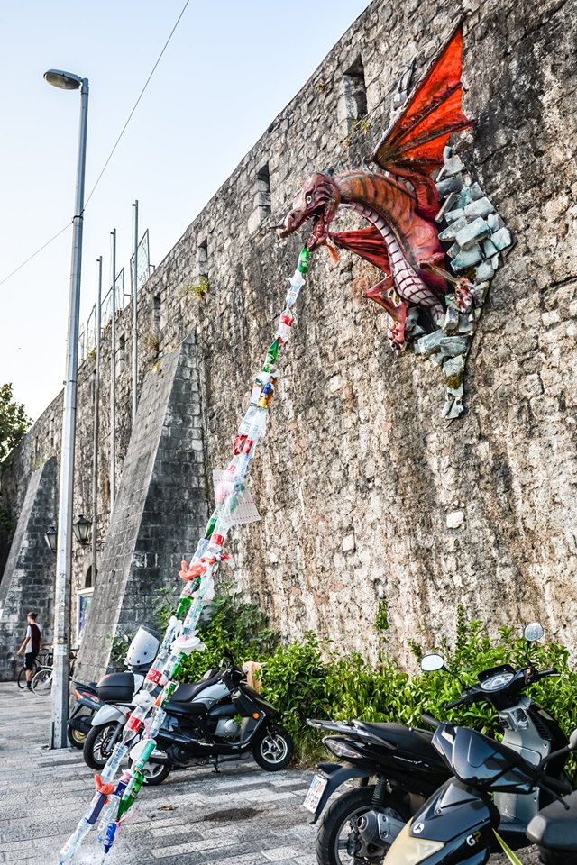
2. Jelly fish (Youth for a clean Adriatic) 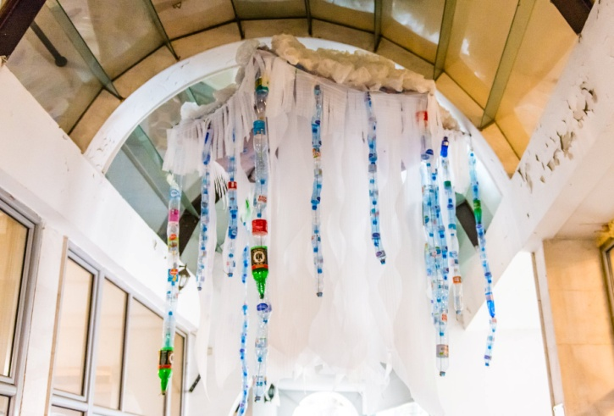
3. Plastic bottle SUP (Youth for a clean Adriatic) 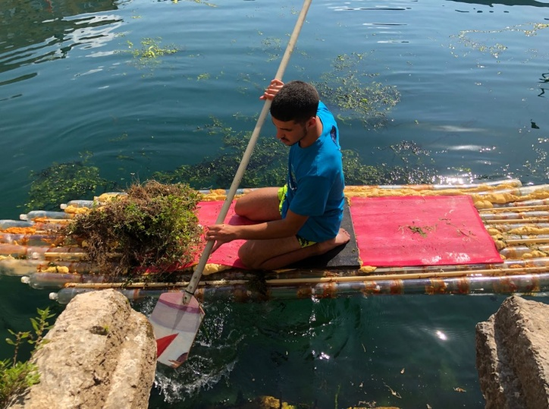
4. Plastic bottle Whale bone (Kotor carneval) 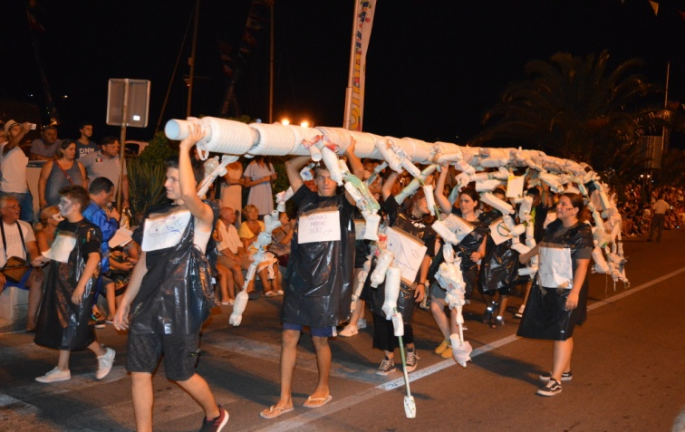
5. Little libraries and living rooms in the open
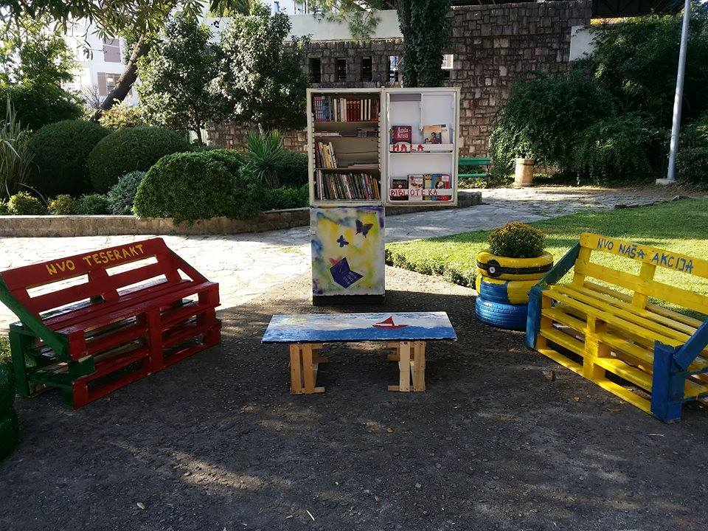
6. Angry Poseidon (Kotor Carneval)
